Bahria University,
Karachi Campus


COURSE: CS-113 COMPUTER PROGRAMMING
TERM: FALL 2022, CLASS: BSE- 1 (B)

Submitted By:
ABDULLAH
02-131222-099
_______________________________________________
(Name) (Reg. No.)
Submitted To:

Engr. Faisal / Engr. Ramsha Mashood

Signed Remarks: Score:

INDEX
SNO | DATE | LAB NO | LAB OBJECTIVE | SIGN
SNO | DATE | LAB NO | LAB OBJECTIVE | SIGN
Bahria University,
Karachi Campus


LAB EXPERIMENT NO.
_______
02
LIST OF TASKS
TASK NO | OBJECTIVE
01 | Write Steps to install Visual Studio
02 | Show the output of all the examples Mentioned in the lab
03 | Write a program to print your profile using C#

Submitted On:
____________
06/10/22
(Date: DD/MM/YY)
Task No. 01: Write step to install visual studio.
STEPS:
- Search Virtual Studio on Internet and click on the Link as shown in picture:
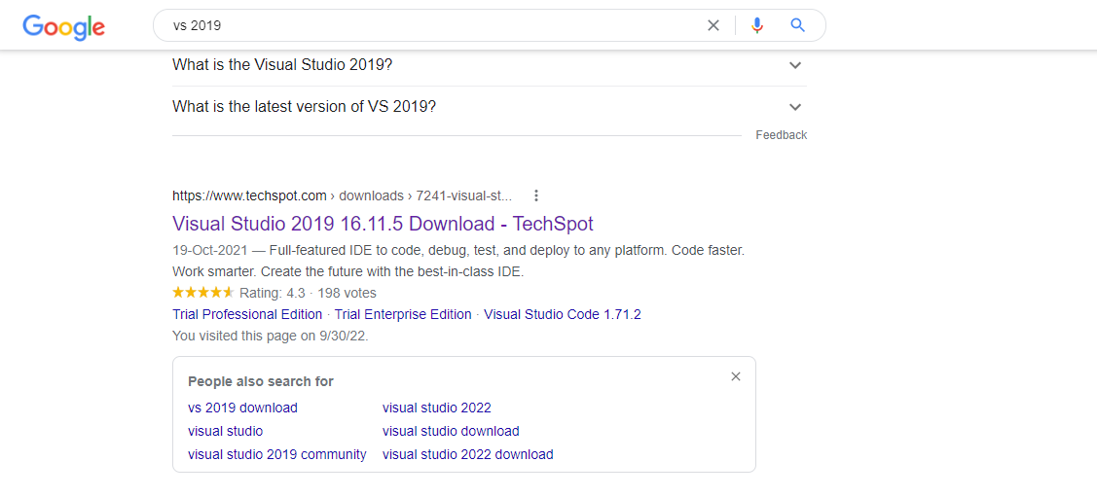
- Click on Free Community Edition and Downloading will start:
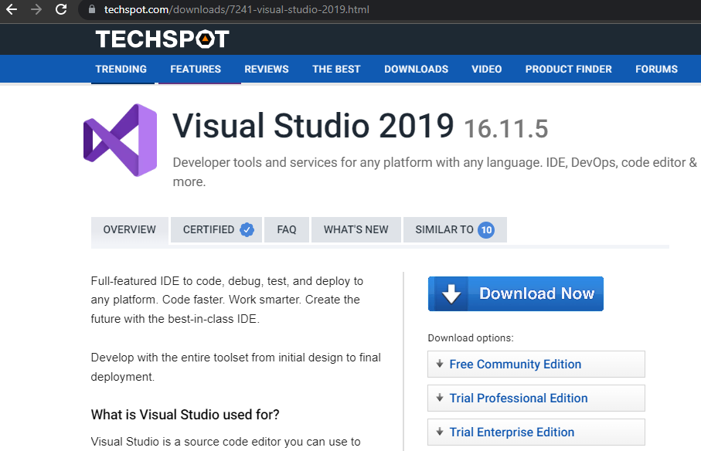

- Now open installation package and Download Visual Studio:
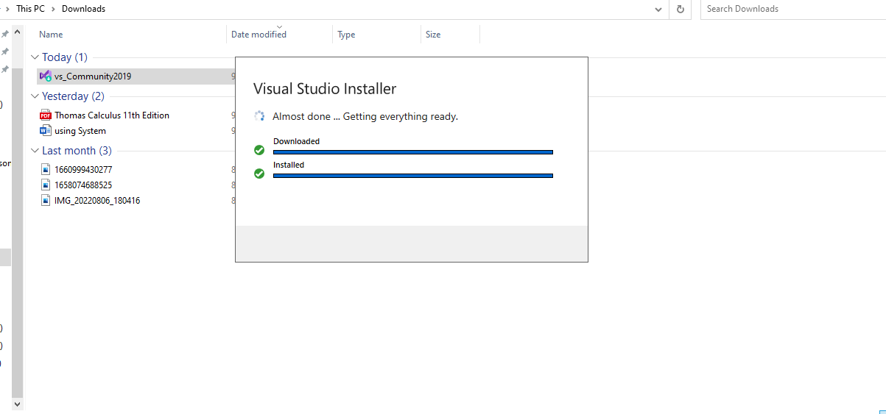
- Now open the visual studio installer and Download .NET desktop Development:
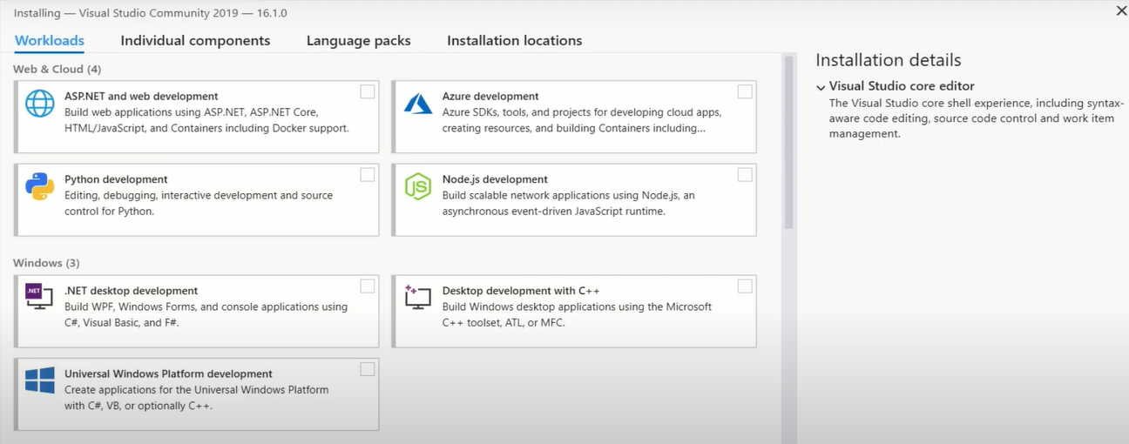
- Visual Studio Will start automatically once it is Downloaded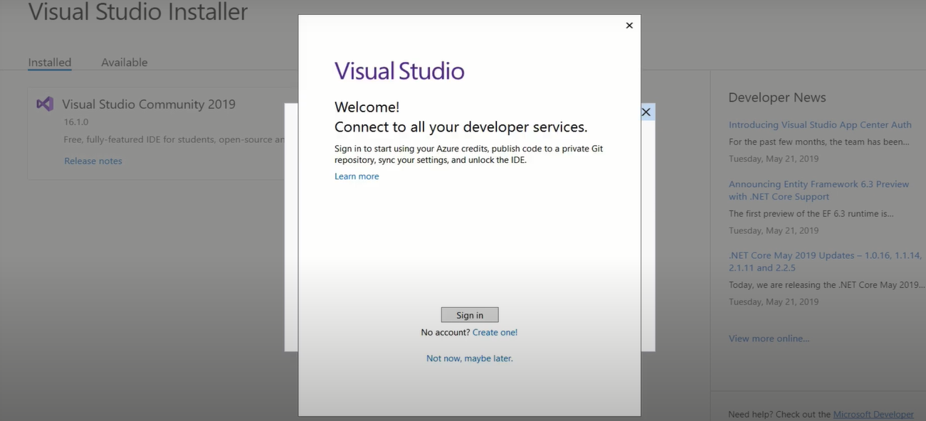

Task No. 02: Output of examples mentioned in the Lab.

Example No 01:
Solution:
using System;

namespace Abdullah_Sadiq
{
class Program
{
static void Main(string[] args)
{
Console.WriteLine("Hello World!");
}
}
}
Output:
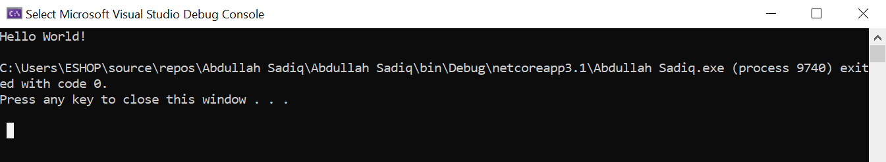
Example No 02:
Input:
using System;

namespace Example_no_02
{
class Program
{
static void Main(string[] args)
{
Console.WriteLine("Abdullah Sadiq");
Console.WriteLine("Age = 17");

Console.Write("Hobby = Photography ");
Console.Write("(Because I like it)");
}
}
}
Output: 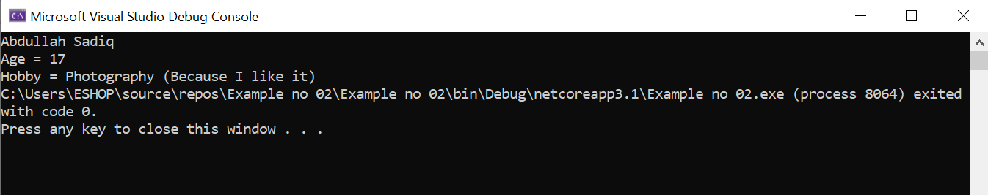

Task No. 03: Write a Program to print your Profile using C#.
Solution:
using System;

namespace Profile
{
class Program
{
static void Main(string[] args)
{
Console.WriteLine("My Profile");
Console.WriteLine(" -My name is Abdullah Sadiq.\n -My Father name is Muhammad Sadiq.\n -I am 17 year old.\n -I have done Fsc from Bahria College(NORE-1).\n -I am a student of Software Engineering at Bahria University(Karachi Campus).\n -My Hobby is Photography. I do it because I like it. ");
}
}
}
Output:
